**Ideation Phase**

**Define the Problem Statements**

|  |  |
| --- | --- |
| Date | 19 September 2022 |
| Team ID | PNT2022TMID51918 |
| Project Name | Project - Customer Care Registry |
| Maximum Marks | 2 Marks |

**Problem Statement**

I am Anuraam. As for the time being, there a lot of budget planner software that are available online but some of these software fall short in helping users to actually create and stick to a budget.

One of the drawbacks is the on-going maintenance, a lot of budget software offer the simplicity of integrating with all users financial accounts and consolidating their activity into one dashboard. However though, some of this existing software mostly have complicated features that are not user friendly.

Also, due to the busy and hectic lifestyle people tend to overlook their budget and end up spending an excessive amount of money since they usually didn’t plan their budget wisely. Last but not least, user cannot predict future expenses. While they can write down their expenses in a piece of paper or manage them in excel spreadsheet, their lack of knowledge in managing finances will be a problem

**Example:**

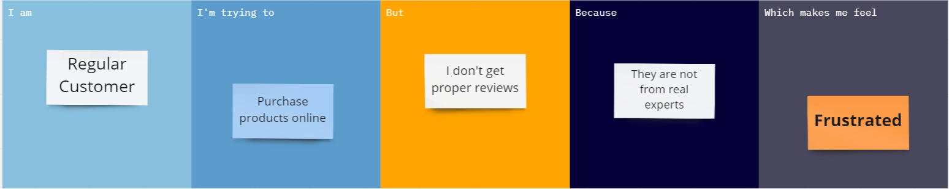

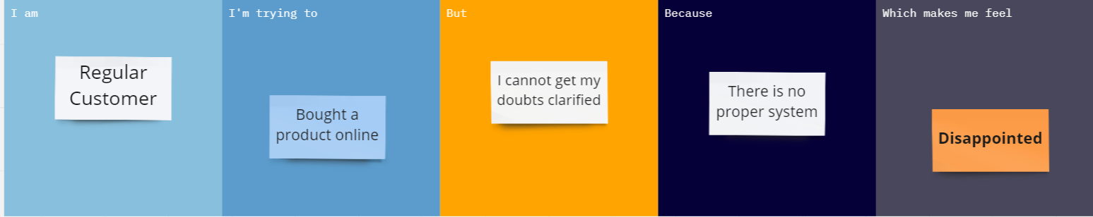

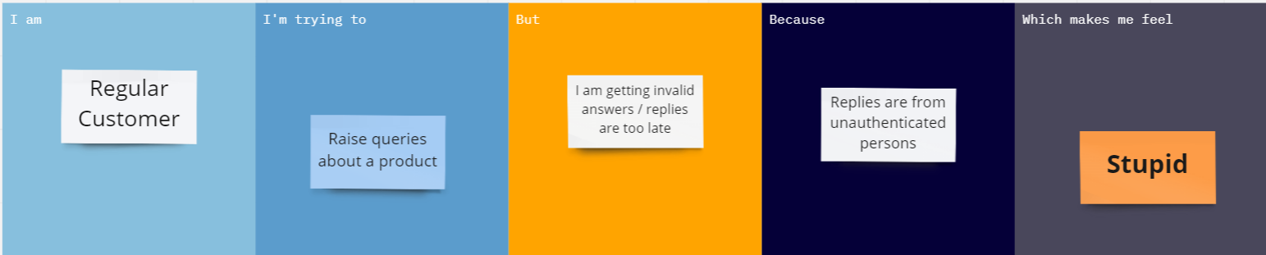

|  |  |  |  |  |  |
| --- | --- | --- | --- | --- | --- |
| **Problem Statement (PS)** | **I am (Customer)** | **I’m trying to** | **But** | **Because** | **Which makes me feel** |
| PS-1 | Regular Customer | Purchase products online | I don’t get proper reviews | They are not from real experts. | Frustrated |
| PS-2 | Regular Customer | Bought a product | I cannot get my doubts clarified | There is no proper system | Disappointed |
| PS-3 | Regular customer | Raise queries about a product | I am getting invalid answers /  replies are too late | Replies are from unauthenticated  persons | Stupid |
|  | | | | | |